# Day - 1

Links to download the application.

https://www.oracle.com/in/java/technologies/downloads/#jdk21-windows

https://git-scm.com/downloads/win

https://maven.apache.org/download.cgi

https://www.jetbrains.com/idea/download/?section=windows

https://developer.hashicorp.com/terraform/install

https://signin.aws.amazon.com/signup?request_type=register

<https://github.com/>

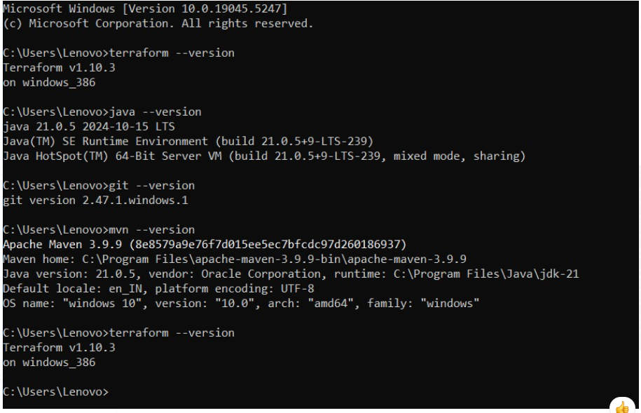====================================

# Config Github

git config --global user.email ""

git config --global user.name ""

# Read Links

<https://aws.amazon.com/solutions/case-studies/makemytrip/?did=cr_card&trk=cr_card>

# 10 Best practice of Github

<https://medium.com/datreeio/top-10-github-best-practices-for-developers-d6309a613227>

# Link to create token github

<https://medium.com/datreeio/top-10-github-best-practices-for-developers-d6309a613227>

# Step to Initiate Github

545 echo "# satyam-ms" >> README.md

546 git init

547 git status

548 git add --all

549 git commit -m "hello"

550 git branch -M master

551 git remote add origin https://github.com/satyam88/satyam-ms.git

552 git push -u origin master

# Concept of SSO

<https://www.youtube.com/watch?v=O1cRJWYF-g4>

# Jenkins

## For Jenkins some repository

https://github.com/satyam88/greentea/blob/master/ami

https://www.jenkins.io/doc/book/platform-information/support-policy-java/

#!/bin/bash

# Define the file paths

FILE="/var/log/server.log"

BACKUP_DIR="/path/to/backup/directory"

# Check if the file exists

if [ -f "$FILE" ]; then

# Create a backup with a timestamp

BACKUP_FILE="${BACKUP_DIR}/server_log_$(date +'%Y%m%d_%H%M%S').bak"

sudo cp "$FILE" "$BACKUP_FILE" # Run this command with sudo to avoid permission issues

echo "Backup of the file created at: $BACKUP_FILE"

else

echo "No existing file to backup."

fi

# Wait for 2 minutes

sleep 120

# Create or recreate the server.log file

sudo touch "$FILE" # Use sudo to create the file with necessary permissions

echo "New server.log file created at: $FILE"